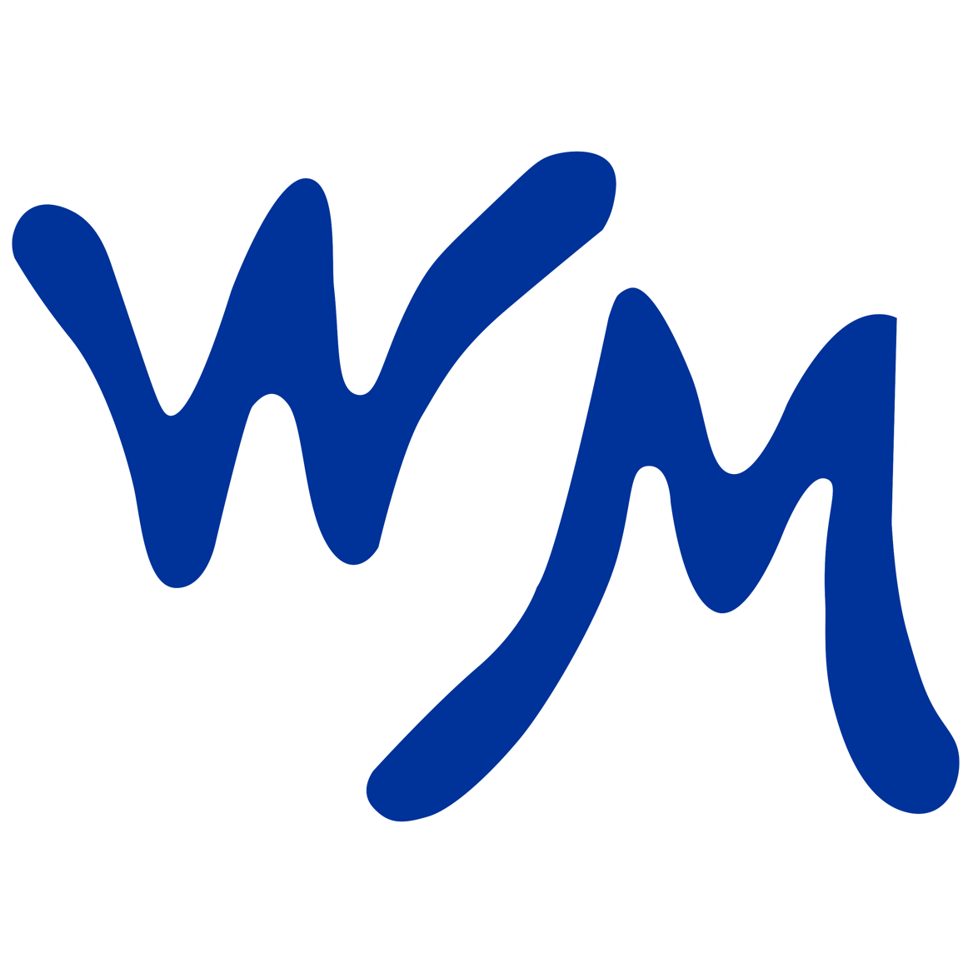
Greater West Melbourne Little League

Sponsorship Program

Spring & Fall ’26

Shelby Kenny
GWMLL SPONSORSHIP COORDINATOR

Dear Prospective Little League Sponsor,

The Greater West Melbourne Little league is a 501(c)(3) organization that promotes the physical and character development of our youth. Designed to establish the values of teamwork, sportsmanship, and excellence, the GWMLL strives to continue the high-quality experience our community has come to know and love.

Established in 1969, the GWMLL is a program with a longstanding tradition of enriching the lives of players, parents, and volunteers alike. As a tradition in West Melbourne for decades, our baseball and softball leagues support hundreds of children and youth each season.

As you know, operating such a program requires a great deal of resources, both manpower and financial support. To keep the registration fee affordable and provide hardship scholarships for families struggling in this economy, West Melbourne relies on community-minded businesses and individuals to partner with us as we seek to remain a positive influence for both this generation and those to come.

Equipment, uniforms, lights, & field maintenance are four of the main operating expenses that depend on business partnerships. Please consider being a sponsor to support Greater West Melbourne Little League for the upcoming season. Your investment will help strengthen a time-tested program for the children in our community! We offer various levels of sponsorships and appreciate you considering ANY of them! If you would like to discuss these or any other sponsorship opportunities, please contact Shelby Kenny, GWMLL Sponsorship Coordinator, at sponsors@gwmll.com; or Nichole Adams, GWMLL Treasurer, at treasurer@gwmll.com.

Thank you for considering a GWMLL Sponsorship!
Let’s have another awesome season at the fields!

Sponsorship Level Options

Team Sponsorship ($400)
- Displays your business’ active web link on the GWMLL website
- 1 appreciation photo plaque with your sponsored team
- Business name placement on the spring season practice jerseys/sponsorship shirt + two sponsorship shirts for the partnered sponsor

Field Sponsorship ($600)
- Displays your business’ active web link on the GWMLL website
- 1 appreciation photo plaque with your sponsored team
- Business name placement on the spring season practice jerseys/sponsorship shirt + two sponsorship shirts for the partnered sponsor
- 1 each 4’ x 8’ banner affixed to 1 of the 7 ballfields

Multi-Field Sponsorship ($800)
- Displays your business’ active web link on the GWMLL website
- 1 appreciation photo plaque with your sponsored team
- Business name placement on the spring season practice jerseys/sponsorship shirt + two sponsorship shirts for the partnered sponsor
- 2 each 4’ x 8’ banners affixed to 2 of the 7 ballfields

Platinum Field Sponsorship ($1000)
- Displays your business’ active web link on the GWMLL website
- 1 appreciation photo plaque with your sponsored team
- Business name listed on practice jerseys/sponsorship shirt + two sponsorship shirts for the partnered sponsor
- 2 each 4’ x 8’ banner affixed to 2 of the 7 ballfields
- Business logo placement on the spring season practice jerseys/sponsorship shirt
- Displays your business’ web link on GWMLL-wide emails
- Full year sponsorship (Both Spring & Fall ’26 Seasons)

League Sponsorship ($2500)
- Displays your business’ active web link on the GWMLL website
- 1 appreciation photo plaque with your sponsored team
- Business name listed on practice jerseys/sponsorship shirt + two sponsorship shirts for the partnered sponsor
- 7 each 4’ x 8’ banners affixed to each of the 7 ballfields
- Displays your business’ web link on GWMLL-wide emails
- Full year sponsorship (Both Spring & Fall ’26 Seasons)
- PRIMARY logo placement on the practice jerseys/sponsorship shirt

Additional sponsorship option: support a player’s registration fee for the season. Contact Shelby Kenny – sponsors@gwmll.com for details

Sponsorship Submissions

Please feel free to submit the sponsorship information, business logo, and payment through the online form linked here or by using the QR code below.


Alternatively, please feel free to submit this form and business logo to Shelby Kenny, GWMLL Sponsorship Coordinator, sponsors@gwmll.com; or Nichole Adams, GWMLL Treasurer, treasurer@gwmll.com & an invoice will be sent to the Sponsor listed below. Payments can be made by cash, check, PayPal*, Square*, or Venmo* (*3% processing fee will apply)
Sponsor Name: _________________________________________________________

Business Address: ______________________________________________________

Sponsor Phone: _________________________________________________________

Sponsor Email: __________________________________________________________

Sponsorship Level: ______________________________________________________
(Sponsorship Level Options listed above)

Payment Type: ____________________ Payment Amount: ____________________

Name of Coach, Team, or Player you would like to Sponsor. If you do not have a specific Coach, Team, or Player to sponsor please enter "GWMLL".

________________________________________________________________________

